**WAP to find the Factorial of given number**

package program1;

import java.util.*;

public class factorial

{

int i,num,fact=1;

public void input()

{

System.out.println("Enter the number for factorail calculation");

Scanner sc=new Scanner(System.in);

num=sc.nextInt();

}

public void show()

{

for(i=num;i>=1;i--)

{

fact=fact*i;

}

System.out.println("Factorial is: "+fact);

}

public static void main(String[] args)

{

factorial f1=new factorial();

f1.input();

f1.show();

}

}

**Output**

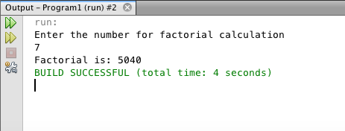

**WAP to generate Fibonacci series**

package program1;

import java.util.*;

public class fibo

{

int num1,num2=0,num3=1,i,temp;

public void input()

{

System.out.println("Enter the Number");

Scanner s1=new Scanner(System.in);

num1=s1.nextInt();

}

public void show()

{

for(i=0;i<num1;i++)

{

temp=num2+num3;

num2=num3;

num3=temp;

System.out.println(temp);

}

}

public static void main(String[] args)

{

fibo f1=new fibo();

f1.input();

f1.show();

}

}

**Output**

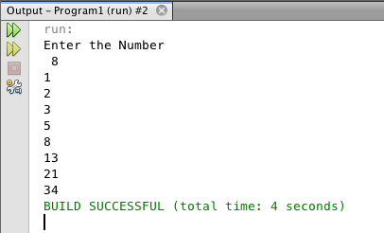

**WAP to check whether number is prime or not**

package program1;

import java.util.*;

public class Primenumber

{

void show()

{

int num1,i,flag=0;

System.out.println("Enter the number");

Scanner s1=new Scanner(System.in);

num1= s1.nextInt();

for(i=2;i<=num1/2;++i)

{

if(num1%i==0)

{

flag=1;

break;

}

}

if(flag==1)

{

System.out.println("Number is not prime");

}

else

{

System.out.println("Number is prime");

}

}

public static void main(String[] args)

{

Primenumber p1= new Primenumber();

p1.show();

}

}

**Output**

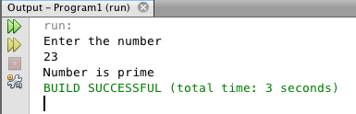

**WAP to check whether the number is palindrome**

package program1;

import java.util.*;

public class palindrome

{

int num,n,sum=0,temp,rem;

public void input()

{

System.out.println("Enter the number");

Scanner s1=new Scanner(System.in);

num=s1.nextInt();

temp=num;

}

public void show()

{

while(num>0)

{

rem=num%10;

sum=(sum*10)+rem;

num=num/10;

}

if(temp==sum)

{

System.out.println("Number is Palindrome");

}

else

{

System.out.println("Number is not palindrome");

}

}

public static void main(String[] args)

{

palindrome p1=new palindrome();

p1.input();

p1.show();

}

}

**Output**

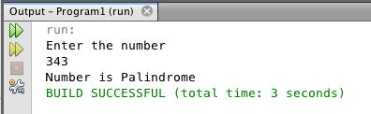

**WAP to check number is Armstrong or not**

package program1;

import java.util.*;

public class armstrong

{

int num,sum=0,temp,rem;

public void input()

{

System.out.println("Enter the numbr");

Scanner s1=new Scanner(System.in);

num=s1.nextInt();

temp=num;

}

public void show()

{

while(num>0)

{

rem=num%10;

sum=sum+(rem*rem*rem);

num=num/10;

}

if(temp==sum)

{

System.out.println("Number is armstrong");

}

else

{

System.out.println("Number is not armstrong");

}

}

public static void main(String[] args)

{

armstrong a1=new armstrong();

a1.input();

a1.show();

}

}

**Output**

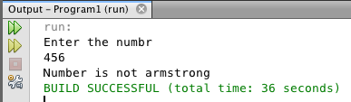

**WAP to print reverse of a Number**

package program1;

import java.util.*;

public class reverse

{

int num,rev;

public void input()

{

System.out.println("enter the number to be reversed");

Scanner s1=new Scanner(System.in);

num=s1.nextInt();

}

public void show()

{

while(num!=0)

{

rev=rev*10;

rev=rev+(num%10);

num=num/10;

}

System.out.println(rev);

}

public static void main(String[] args)

{

reverse r1=new reverse();

r1.input();

r1.show();

}

}

**Output**

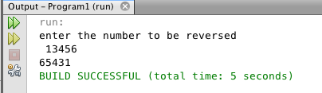

**WAP to print the series of prime number**

package program1;

public class primelist

{

public static void main (String[] args)

{

int i =0;

int num =0;

String primeNumbers = "";

for (i = 1; i <= 50; i++)

{

int counter=0;

for(num =i; num>=1; num--)

{

if(i%num==0)

{

counter = counter + 1;

}

}

if (counter ==2)

{

//Appended the Prime number to the String

primeNumbers = primeNumbers + i + " ";

}

}

System.out.println("Prime numbers from 1 to 50 are :");

System.out.println(primeNumbers);

}

}

**Output**

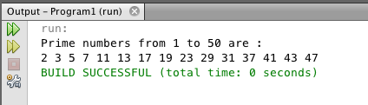

**WAP to print reverse of a sting**

package program1;

import java.io.*;

import java.util.*;

public class reversestring

{

public static void main(String args[])

{

String orig, rev="";

int i, len;

Scanner scan = new Scanner(System.in);

System.out.print("Enter a String to Reverse : ");

orig = scan.nextLine();

len = orig.length();

for(i=len-1; i>=0; i--)

{

rev = rev + orig.charAt(i);

}

System.out.print("Reverse of Entered String is : " +rev);

}

}

**Output**

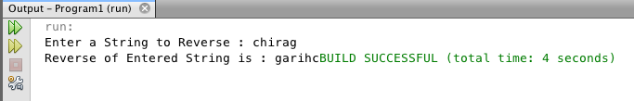

**WAP to print pattern using “ * “**

public class pattern

{

public void show()

{

for(int i=5;i>=1;i--)

{

for(int j=1;j<i;j++)

{

System.out.print(" ");

}

for(int k=5;k>=i;k--)

{

System.out.print("*");

}

System.out.println();

}

}

public static void main(String[] args)

{

pattern p1=new pattern();

p1.show();

}

}

**Output**

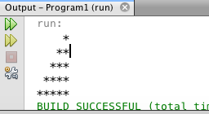

**WAP to print triangle**

package program1;

public class pattern1

{

public void show()

{

for(int i=1;i<=5;i++)

{

for(int j=i;j<5;j++)

{

System.out.print(" ");

}

for(int k=1;k<(i*2);k++)

{

System.out.print("*");

}

System.out.println();

}

}

public static void main(String[] args)

{

pattern1 p1=new pattern1();

p1.show();

}

**Output**

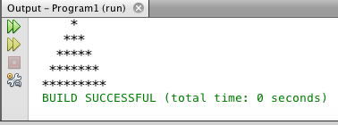

**WAP to print inverted triangle**

package program1;

public class pattern2

{

public void show()

{

for(int i=1;i<=5;i++)

{

for(int j=i;j<5;j++)

{

System.out.print(" ");

}

for(int k=1;k<(i*2);k++)

{

System.out.print("*");

}

System.out.println();

}

for(int i=4;i>=1;i--)

{

for(int j=5;j>i;j--)

{

System.out.print(" ");

}

for(int k=1;k<(i*2);k++)

{

System.out.print("*");

}

System.out.println();

}

}

public static void main(String[] args)

{

pattern2 p1=new pattern2();

p1.show();

}

}

**Output**

